|  |
| --- |
| Farm DeFi on Cardano Project scope |



Kevin Kinyua

[kevin@kimcotech.com](mailto:kevin@kimcotech.com)

16/04/2021

Dear [ WHOM IT MAY CONCERN]

Please ﬁnd enclosed our detailed software scope of work for your kind consideration.

At KIMCO TECHNOLOGIES we are aware that creating client-oriented software takes a mixture of technical excellence and clear communication between service and our users thusly our ﬁrm puts in the work to ensure we achieve both. We know that every partner is unique and we strive to deliver an innovative proposal statement and to follow it through with an outstanding delivery which is both on time and within budget.

Please let us know if you would like to get in touch with our existing clients from whom you will receive nothing but positive endorsements. You may also wish to review our website at [**www.kimcotech.com**](http://www.kimcotech.com)to see our portfolio of previous work and learn more about our organization.

We also pride ourselves on our after-sales client-care including our guarantees, staff-training and onsite and offsite support.

Finally, we realize that you are very busy and wanted to thank you in advance for your time spent reviewing our proposal and scope of work.

Kevin Kinyua

KIMCO TECHNOLOGIES

+254-723 052 500

# 

# **Executive Summary**

The East African Digital space is an ever-growing monolith of data and opportunity. In this day and age, information and services become easier to access with each growing iteration development of the web and mobile space. This provides more opportunities to fill entrepreneurial gaps in variety of industries that are data centric. In the Agricultural industry for example, there is the challenge that participants along the value chain have that comes with monitoring the yields of the farm as well as enabling small scale farmers with low interest loans to cover the costs of farming that the farmers could find strenuous.

Farm DeFi (Decentralized Finance) addresses this by deploying strategies to move assets between different real-time yield farming opportunities, providing real-time PLAAS Farmers with funds & insurance as well as maximizing Digital assets & Farm Animal/Crop yield.

FARM DeFi is a decentralized yield farm product for PLAAS Farmers Tokens & ecosystem with the highest APY on real farm products. It covers the;

* Tracking & responding to yield farming opportunities can be a full-time job.
* Gas costs are increasing, moving in-between farming opportunities is becoming prohibitively expensive.

# 

**Project Description**

We are pleased to offer this web application scope and proposal for your review. On this technical scope, you'll find details regarding the tentative design timeline for your project. In the web application we will cover the following modules.

The project will be developed on the Cardano Blockchain Protocol. Cardano works on a specially designed proof-of-stake (PoS) blockchain protocol for consensus called Ouroboros. This consensus mechanism allows for ada cryptocurrency (which will be the main token) to be sent and received easily and securely at all times, while also ensuring the safety of smart contracts on the Cardano blockchain. In Ouroboros, there is no race between stakeholders to produce a block. Instead, a slot leader is randomly selected, proportionally to the amount of tokens he/she owns (the stake), to get the opportunity to produce a new block.

The Cardano blockchain can be used to build smart contracts, and in turn, create decentralized applications and protocols. Additionally, the ability to send and receive funds instantly through, for minimal fees, have many applications in the world of business and finance. It solves the challenges of scalability, sustainability and interoperability. This essentially makes Cardano versatile to the needs of this particular project.



**The Technology**

We intend to use MEAN Stack to develop the proposed software. This a free and open-source JavaScript software stack for building dynamic web sites and web applications. Which includes

* 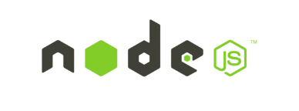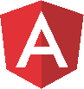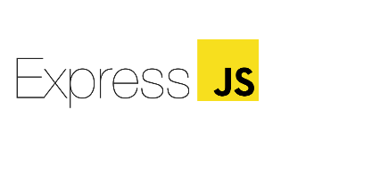****Mongo DB
* Express JS
* Angular
* Node JS

**Angular framework** is a TypeScript-based open-source web application framework led by the Angular Team at Google and by a community of individuals and corporations for building single-page client applications. The architecture of an Angular application relies on certain fundamental concepts. The basic building blocks are NgModules, which provide a compilation context for components.

As for the database we will either use **Mongo DB**. It makes it easier to pass data between client and server by saving data in binary JSON format. The concept on which it works is collection and documentation. MongoDB provides high performance, high availability, and easy scalability because it is a cross-platform, document-oriented database. To adopt JSON-like documents which have BSON (dynamic schemes) MongoDB shuns the relational database’s table-based structure, which makes data integration for certain types of applications faster and easier.

**Node JS** is lightweight and efficient because it uses an event-driven, on-blocking I/O model. Chrome’sV8 JavaScript engine is used to build JavaScript runtime. It has the largest ecosystem of open source libraries in the world known as npm. It can also run JavaScript applications outside the browser. It is a cross-platform runtime environment. It is free to use is open source.

**Express JS** is a web application framework for Node.js, released as free and open-source software under the MIT License. It is designed for building web applications and APIs. It has been called the de facto standard server framework for Node.js.

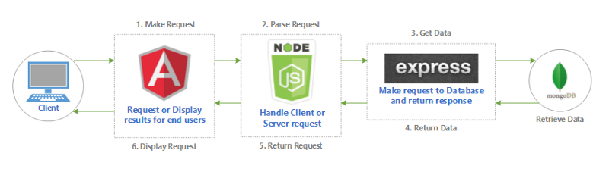

**Why use MEAN Stack?**

While each of the listed technologies can be used as a standalone solution, they really shine when used in a bundle. Namely, the MEAN.JS stack offers the following benefits for business owners:

1. **Reduced development cost:** It is completely open source and free to use. One of the main benefits a business can get out of using the MEAN stack is overall lower expenses.
2. **Fast MVP development and scalability:** In addition to a fast time to market, the MEAN stack provides a solid foundation for building scalable software products. A large number of additional frameworks, libraries, and reusable modules are available within the stack which contributes to increased development speed: ready-made solutions can significantly save time while making development less strenuous.
3. **Excellent performance:** Node.js, the heart of the MEAN stack, is known for its outstanding performance. According to a number of benchmarks, the technology outperforms a number of other backend programming languages, including PHP, Python, and Ruby

**DISCLAIMER:**  Depending on the interoperability of the project, the developers may change the nature of the stack to accommodate the time frame as well as to accommodate the technological capacity of users that may use the DeFi Platform. Other Stacks could be Android, Flutter, and/or PHP.



# **Milestones and Timeline**

|  |  |  |  |
| --- | --- | --- | --- |
| Milestone | Tasks | Reporting | Duration (Days) |
| 1 | Analysis stage |  | 1 |
| 2 | Definition of scope of work and planning |  | 1 |
| 3 | Architecture design and prototyping |  | 3 |
| 4 | Software Development implementation |  | 30 |
| 5 | Integration of services |  | 10 |
| 6 | Testing (Functional and Non-Functional tests) |  | 10 |
| 7 | Software Deployment and Launch |  | 5 |
| 8 | Maintenance and Updates |  | - |
| TOTAL NUMBER OF DAYS | | | 60 |

# 

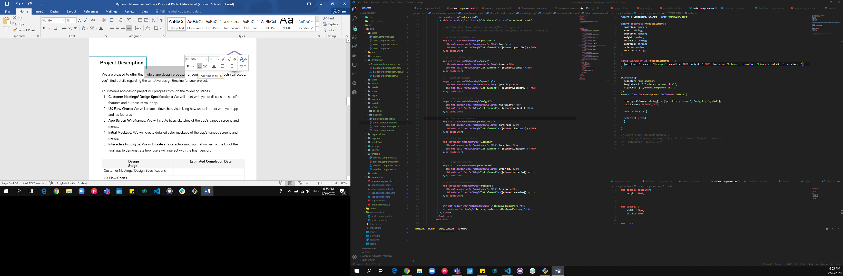**Financial**

We develop the web application services on a per-hour basis. Hours will be billed on a weekly basis throughout the project. At this stage of the partnership we will absorb the cost of development up until deployment. We (Dynamic Alternatives) will device a transactional cost module in the application once we deploy for mutual partnership benefit.

The pricing table below shows the rate for each project role, along with an estimated number of the hours required to complete the project

**Conclusion**

We look forward to the development and completion of this project. The potential of Blockchain feature to secure record and engender trust between the value chain participants as well as enabling a decentralized hub of credit for farmers that will eventually enhance agricultural growth in the region.